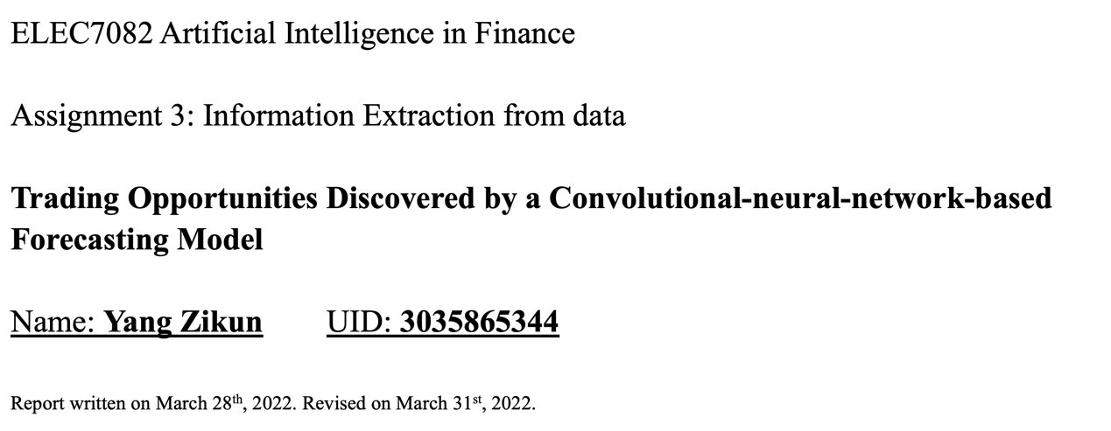

**Detailed Report & Supporting Materials**

**Content List**

*Abstract of Major Findings* ........................................................................................ -1-

*Methods (Applied machine learning algorithms)* ....................................................... -2-

*Results (Supporting data & materials)* ...................................................................... -5-

*Coding details (Python & Pytorch codes)* ................................................................. -8-

**Abstract of Major Findings**

1. A neural network model is developed to predict whether the close price will be higher than the open price tomorrow based on the past-day information.
2. Experimental results support that the best input length of the past days is 10 days. And for the format of the input, the information should be better placed sequentially by “low, open, close, high” as the four columns, forming a $4×10$ matrix.
3. The neural network model is applied independently to 8 indexes (AEX25, CHINAA50, DJI, HSI, IBEX35, JP225, Russell2000, and SSGF3). Predictable patterns are discovered in only four indexes, SSGF3, DJI, AEX25, and Russell2000. The forecasting accuracy in those four indexes are 65.137%, 63.709%, 64.646%, and 63.503%, respectively.
4. For the other four indexes (CHINAA50, HIS, IBEX35, and JP225), this neural network model does not discover any predictable pattern on forecasting future growths. Compared with the traits of the data, an explanation is that the index with much lower values, lower variance, and more stable trend can be easier to forecast.
5. A trading strategy on the SSGF3, DJI, AEX25, and Russell2000 indexes is, we first input the past-10-day price information to this neural network, if the neural network shows a positive output, tomorrow we can buy-in when market opens and sell-out right before the market closes, to make profits.

**Methods**

1. *Overview of the methods*

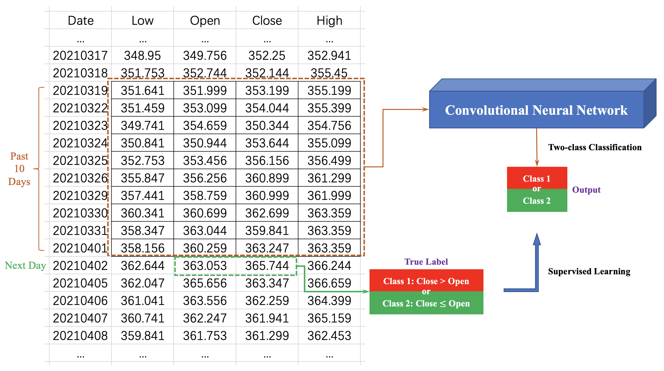

**Figure 1.** An overview of the forecasting methods.

**Figure 1** shows how the machine learning strategy is implemented to extract predictable patterns in the provided index.

The inputs to this convolutional neural network are the index information during the past ten days. The four columns sequentially represent the lowest price, open price, close price, and the highest price. The 10 rows sequentially list those four values for each of the past ten days. Those $10×4=40$ values will be treated as a matrix and then input to the neural network.

The neural network output is a two-class classification, denoting whether the close price will be higher than the open price tomorrow. Here I use the next day’s information of the open and close prices as the supervisor. Class 1 means that tomorrow the close price will be higher than the open price. Class 2 means that tomorrow the close price will be lower than the open price.

The neural network is trained by supervised learning. This study will treat difference indexes (i.e., SSGF3 and DJI) separately. The training and testing will be conducted within one certain index, and no cross-indexes training is included. The first 85% days are used for training, while the last 15% days are used for testing, which obeys that the future prediction will only be based on the training of the past days in the time-serried data.

If in a certain index, this neural network model shows good accuracy in the testing data, this means that the future growing opportunities can be forecasted by this model. We can use the neural network model predict whether the close price will be higher than the open price tomorrow based on the price records of the past ten days in this index.

The corresponding trading strategy is that, for a certain index, we first train a neural network model based on the past records. We input that matrix of the lowest prices, open prices, close prices, and the highest prices of the past 10 days into this neural network. If the neural network gives us a positive prediction, there can be a great possibility that the close price will be higher than the open price tomorrow. In that case, we can buy-in when the market opens and sell-out right before the market closes to make profits.

1. *Neural network implementation details*
2. *Neural network structure*

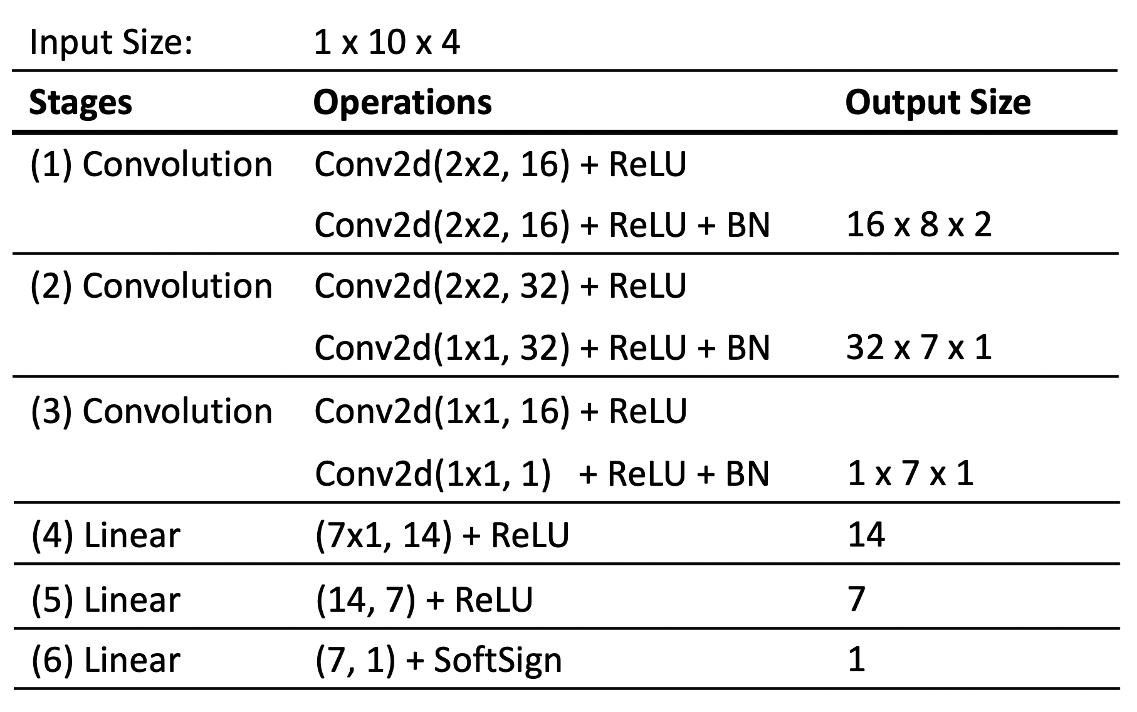

**Figure 2.** Structure details of the convolutional neural network.

**Figure 2** illustrate the structural details of the convolutional neural network model in this study. This neural network starts with 6 convolutional kernels, then followed by a three-layer linear structure, and the final output is a single value to denote the classification (closer to 1 or closer to 0). The convolutional layers will at first have a growing number of convolutional channels, then reducing to a one-channel single feature map ($1→16→32→1$), which is a common structure for feature extraction. The following multi-layer linear structure will slowly summarize this feature map into a single value to function as the classification unit.

In the internal layers, ReLU activation functions are implemented. I also add three Batch Normalization (BN) layers in between the convolutions to help with the training. The last activation function at the output is SoftSign (from the experimental results, SoftSign shows better accuracy than Sigmoid, however Sigmoid shows better ROC curves).

1. *Dataset pre-processing*

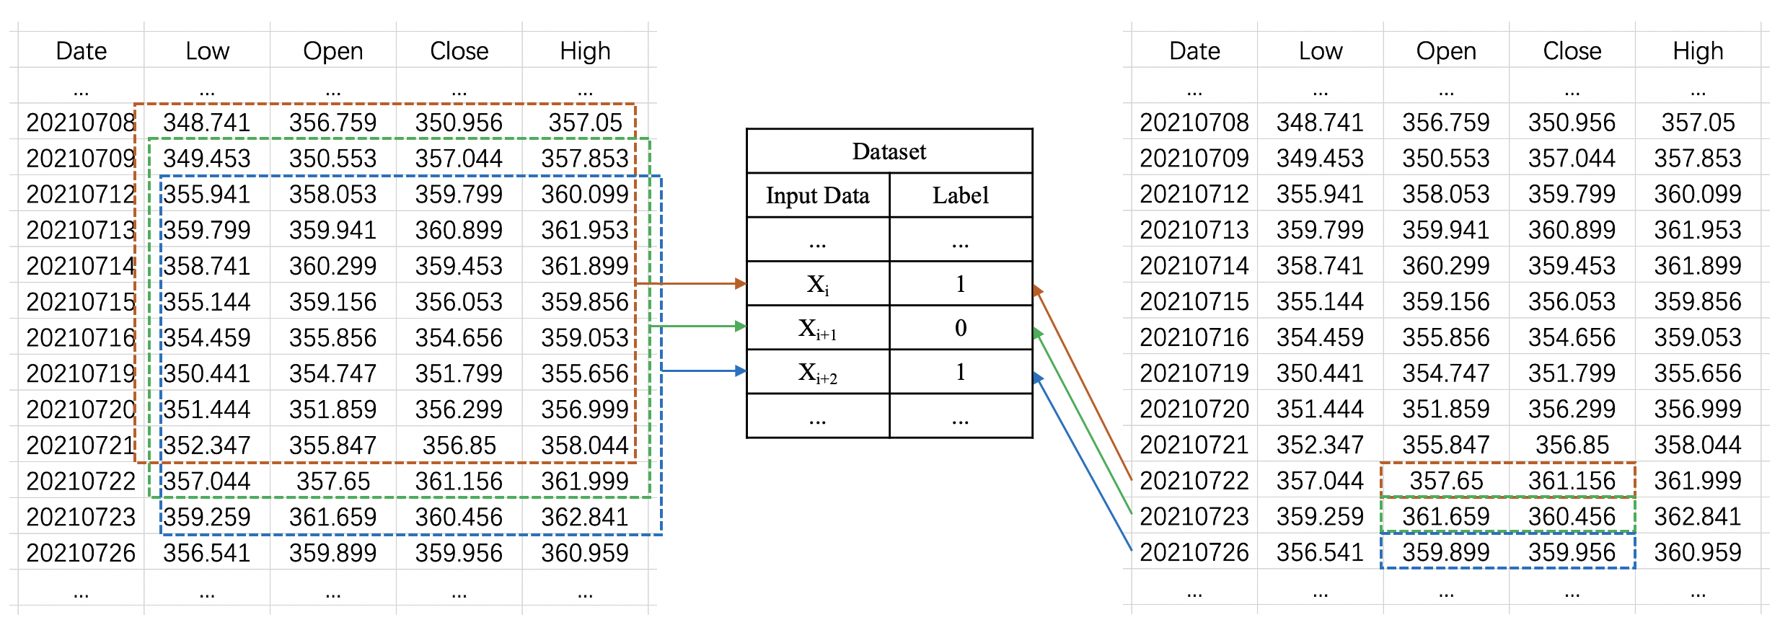

**Figure 3.** Index data pre-processing to create the dataset.

**Figure 3** shows how the dataset is pre-processed and created. Every consecutive 10 days is documented as the input side. For each input, the output label is denoted as “1” if its next day’s close price is higher than the open price. On the other hand, the output label is denoted as “0” if its next day’s close price is lower than the open price.

When dividing the dataset into training dataset and testing dataset, the sequential order must NOT be changed to make sure the training data is in the past. But during the training we can use batch training and shuffling inside the training dataset.

1. *Training process details*

Python language and Pytorch library are implemented to build the neural network model and code the training and testing process. Detailed codes are appended to this report and are also uploaded to the Moodle submission.

For other training parameters: (1) The weights of the neural network are initialized by Kaiming He’s methods. (2) The neural network is trained by supervised learning to reduce the difference between the neural network outputs and the true labels. (3) Mean square error is used as the loss function (from the experiment, this is better than cross entropy loss). (4) Adam is used for the optimizer. (5) The batch size is 128. (6) For each one of the indexes, the model will be trained at a learning rate of 0.001 for 7000 epochs, then a learning rate of 0.0001 for 3000 epochs, and in the end a learning rate of 0.00001 for the last 3000 epochs.

1. *Evaluation standards*

The first 85% days in the dataset are used for training, while the last 15% days in the dataset are used for testing. For the convenience of training and testing, the exact number of data in each training and testing datasets will be round-off to a close decuple integer.

The performance is mainly evaluated by the accuracy in the testing dataset, the ROC curve plotted by thresholds from 0 to 1, and also the confusion matrix.

A good result might indicate that in the corresponding index, there exists predictable patterns to forecast the future growths based on the past-day values.

**Results**

1. *“Low, open, close, high” is the best input placing order*

Since the neural network is convolutional-based, the sequential order of how the four columns is placed might impact the forecasting ability (**i.e., if the open and close prices are not nearby each other, they will not be convoluted together in the first layer**). Here I use the past-10-day values for every case, while adjusting how we place the four columns of the open, close, low, and high prices, to test the best way for presenting the information to the neural network (knowledge representation).

Here we use the “DJI” index to do a simple try out. The best accuracy is observed when we place the past-10-day values with an order of “Low, Open, Close, High”. Basically, it seems like the results will be better if we put the open price and close price nearby each other, and in the middle. An explanation might be that the open and close price are more important in this forecasting model.

|  |  |  |  |  |
| --- | --- | --- | --- | --- |
| **Order of the four columns (10 days)** | | | | **Accuracy on DJI index** |
| Open | Close | Low | High | 56.451% |
| Close | Open | Low | High | 54.838% |
| Close | Open | High | Low | 55.645% |
| Open | Close | High | Low | 59.677% |
| Low | Open | Close | High | 63.709% |
| Low | Close | Open | High | 57.258% |
| Open | Low | Close | High | 50.806% |
| Open | High | Close | Low | 52.419% |
| Open | Low | High | Close | 46.875% |
| Open | High | Low | Close | 50.000% |

1. *A length of 10 days is the best input length*

Different lengths of the past days are tested to explore the best number of past days that can achieve the best forecasting accuracy. Here I adjust the number of past days from 3 to 20 to check with the performance. I use the order of “Low, Open, Close, High” to place the four columns. I still test the model on the DJI index.

The forecasting accuracy might not be good if the input length is too short or too long. At least we need the data of the past one week to observe patterns. However, the data from two weeks ago might not be useful. Here, the input lengths of 10, 12, and 15 days can have nearly the same good accuracy. To achieve the best computing efficiency, I select the length of past 10 days to be the neural network input.

This result might reveal that in the market the values within two weeks might be closely related to each other.

|  |  |  |  |  |  |  |  |  |
| --- | --- | --- | --- | --- | --- | --- | --- | --- |
| **Input days** | 3 | 5 | 7 | 10 | 12 | 15 | 17 | 20 |
| **Accuracy (%)** | 52.419 | 54.032 | 60.483 | 63.709 | 62.096 | 62.903 | 59.677 | 58.870 |

1. *Experimental results*

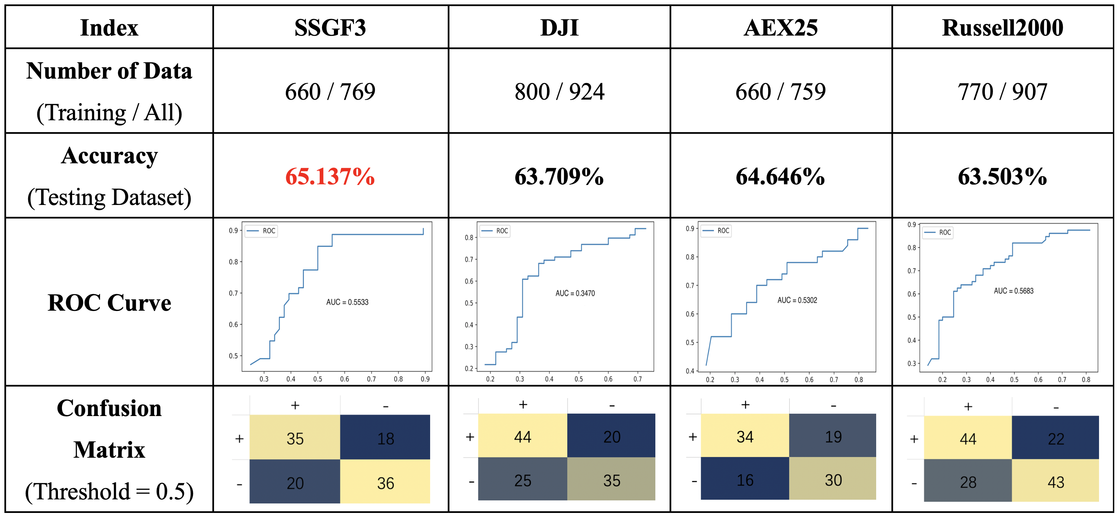

**Figure 4.** Overall results.

Here I use the input length of past 10 days and place the four columns in the order of “Low, Open, Close, High” (identical with the methods section) to explore potential predictable data patterns in the provided indexes. Due to the time limit of this Assignment 3, I select 8 indexes including AEX25, CHINAA50, DJI, HSI, IBEX35, JP225, Russell2000, and SSGF3 to conduct the experiments.

Among those 8 indexes, only 4 of them, AEX25, DJI, Russell2000, and SSGF3 show good accuracy in the testing dataset. This neural network model does not discover any predictable patterns in the other four indexes (usually the training can be completed, and the loss function can be converged, but the accuracy in the testing dataset is bad). The forecasting accuracy in the test dataset, the ROC curve, and the confusion matrix of those four indexes are shown in **Figure 4**.

When using 85% of the past data for training, we can observe 65.137% accuracy in SSGF3, 63.709% accuracy in DJI, 64.646% accuracy in AEX25, and 63.503% accuracy in Russell2000. These prediction accuracies are acceptable for a finance forecasting mode, given the so many uncertainties in the field of finance. The 65.137% accuracy in the SSGF3 index means that there is great potential that we can make money in this market based on this neural network model.

Compared with the accuracy, the ROC curve is not good for all the indexes. All the AUC values are not good enough from the machine learning perspective. One reason is that the final prediction accuracy can be severely impacted by the threshold value. Also, even if I use an extreme high / low threshold value, I cannot filter out the wrongly predicted negatives / positives. In my experiment, using Sigmoid activation function can enhance the ROC curves, however this will sacrifice the forecasting accuracy.

The confusion matrix shows that for all the four indexes, the trained model and discovered patterns are balanced in the forecasting of different classes.

1. *Results evaluation and analysis*

Using neural network to explore the hidden patterns in the market can be useful. In this work, the experimental results support that there is good potential to forecast future growths based on the past-day values in the AEX25, DJI, Russell2000, and SSGF3 indexes. By inputting the past-10-day low, open, close, and high prices into the neural network, the model can forecast whether the close price tomorrow will be higher than the open price. Consequently, the trading strategy is to buy-in when the market opens, and sell-out right before the market closes, if the model predicts a positive result based on the past-10-day values.

Among the 8 indexes I tested with the neural network model, I only discover predictable patterns in the four indexes, AEX25, DJI, Russell2000, and SSGF3, with varied accuracy. The following Table presents some obvious data traits among the 8 indexes, along with their neural network model experimental results.

Based on these data and the neural network forecasting results, I have the following assumptions about how likely a machine learning strategy can work in a certain market (just assumptions, not 100% right):

1. Besides DJI, all the three other indexes that with predictable patterns have much smaller market prices. Maybe in those lower-price indexes it will be easier to forecast future potential growths. Maybe in the larger market, the uncertainties are much more than the smaller market.
2. In the predictable indexes, the data plots show overall growing / stable trends. On the other hand, the growing or decreasing trends in HIS and CHINAA50 are varied from time to time. And in the neural network result, those two indexes show the worst performance. Hence, if there is a relatively stable trend in the past data, maybe this index will be easier to predict.
3. In the non-predictable indexes, we can observe higher variance than the other four predictable indexes in the data plot. Maybe when forecasting the future growths, we shall select the indexes with lower variance.

|  |  |  |  |  |
| --- | --- | --- | --- | --- |
| **Index** | **Average Prices** | | **Data Plot** | **Neural Network Result** |
| **SSGF3** | Low | 340.759 |  | Patterns Found  65.137% accuracy |
| Open | 343.352 |
| Close | 343.296 |
| High | 345.735 |
| **DJI** | Low | 28896.403 |  | Patterns Found  63.709% accuracy |
| Open | 29088.784 |
| Close | 29107.481 |
| High | 29277.742 |
| **AEX25** | Low | 614.441 |  | Patterns Found  64.646% accuracy |
| Open | 618.779 |
| Close | 619.106 |
| High | 622.964 |
| **Russell**  **2000** | Low | 1756.207 |  | Patterns Found  63.503% accuracy |
| Open | 1773.597 |
| Close | 1774.842 |
| High | 1790.253 |
| **HSI** | Low | 26397.416 |  | Not Predictable  (Neural network can be trained, but only 44% in testing data) |
| Open | 26635.791 |
| Close | 26630.989 |
| High | 26858.931 |
| **CHINA**  **A50** | Low | 14722.617 |  | Not Predictable  (Neural network failed to converge, cannot be trained) |
| Open | 14869.561 |
| Close | 14876.232 |
| High | 15014.739 |
| **IBEX35** | Low | 8424.463 |  | Not Predictable  (Neural network can be trained, but only 53% in testing data) |
| Open | 8492.249 |
| Close | 8491.250 |
| High | 8555.420 |
| **JP225** | Low | 24208.993 |  | Not Predictable  (Neural network can be trained, but only 49% in testing data) |
| Open | 24394.361 |
| Close | 24407.422 |
| High | 24571.560 |

**Coding Details**

Here I present the screenshot of the coding details and the original experimental results in the Jupytor Notebook. I also uploaded the Python & Pytorch source code file, “Python Codes Yang Zikun” to the Moodle Submission.

Here I only use the “DJI” index for an example. For other indexes, the codes are nearly the same, only need to alter the input data.

1. *Utilized tools and packages*

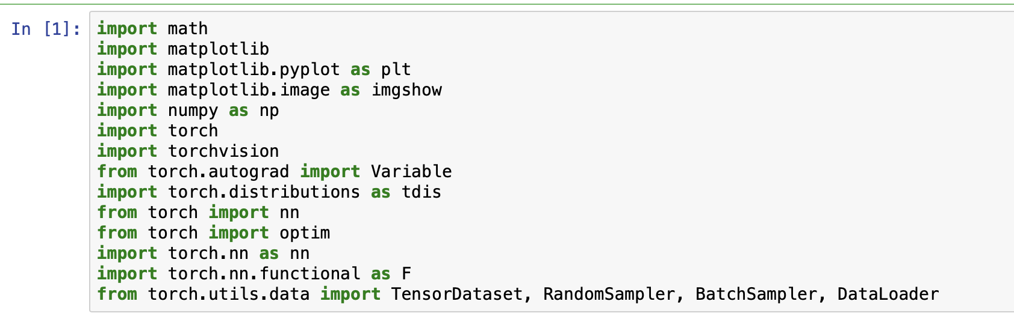

This machine learning model is coded by Python language. Pytorch library is the main tool to construct, train, and test the neural network model.

1. *Data loading & pre-processing*

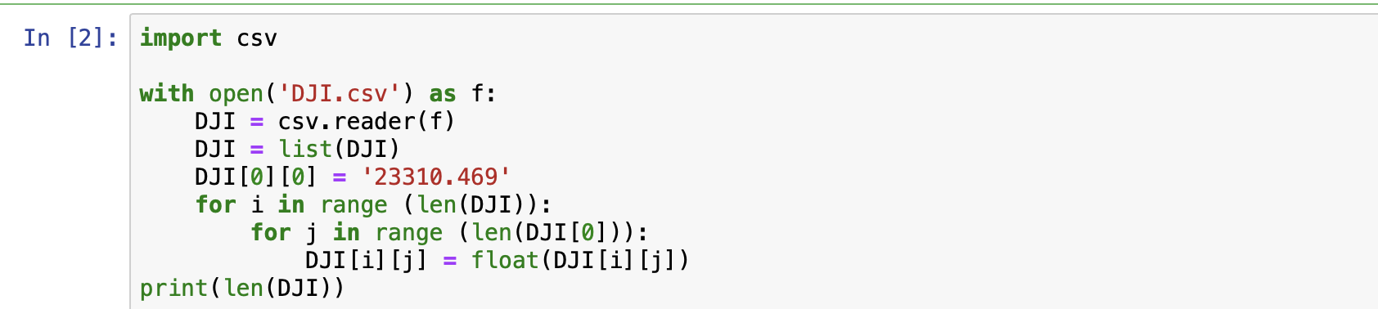

The index is stored in .csv file, and first converted into a float list.

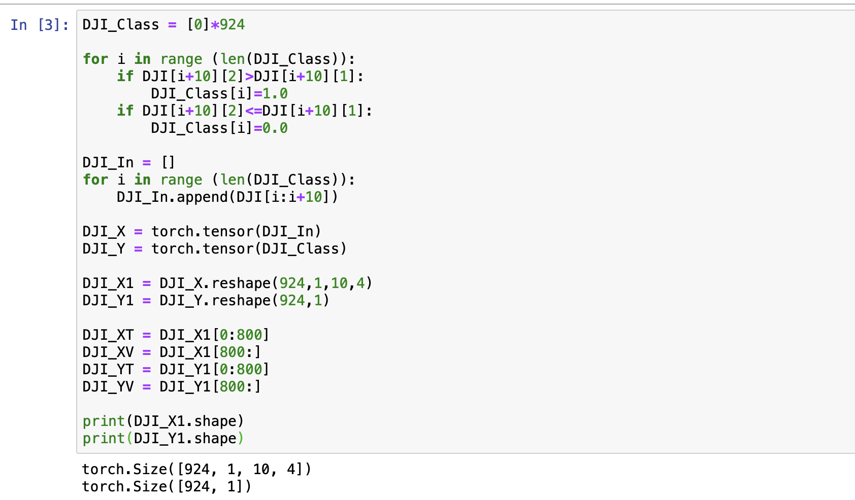

Here, the first 800-day data is put into the training dataset, and the rest days are put into the testing dataset.

1. *Neural network construction*

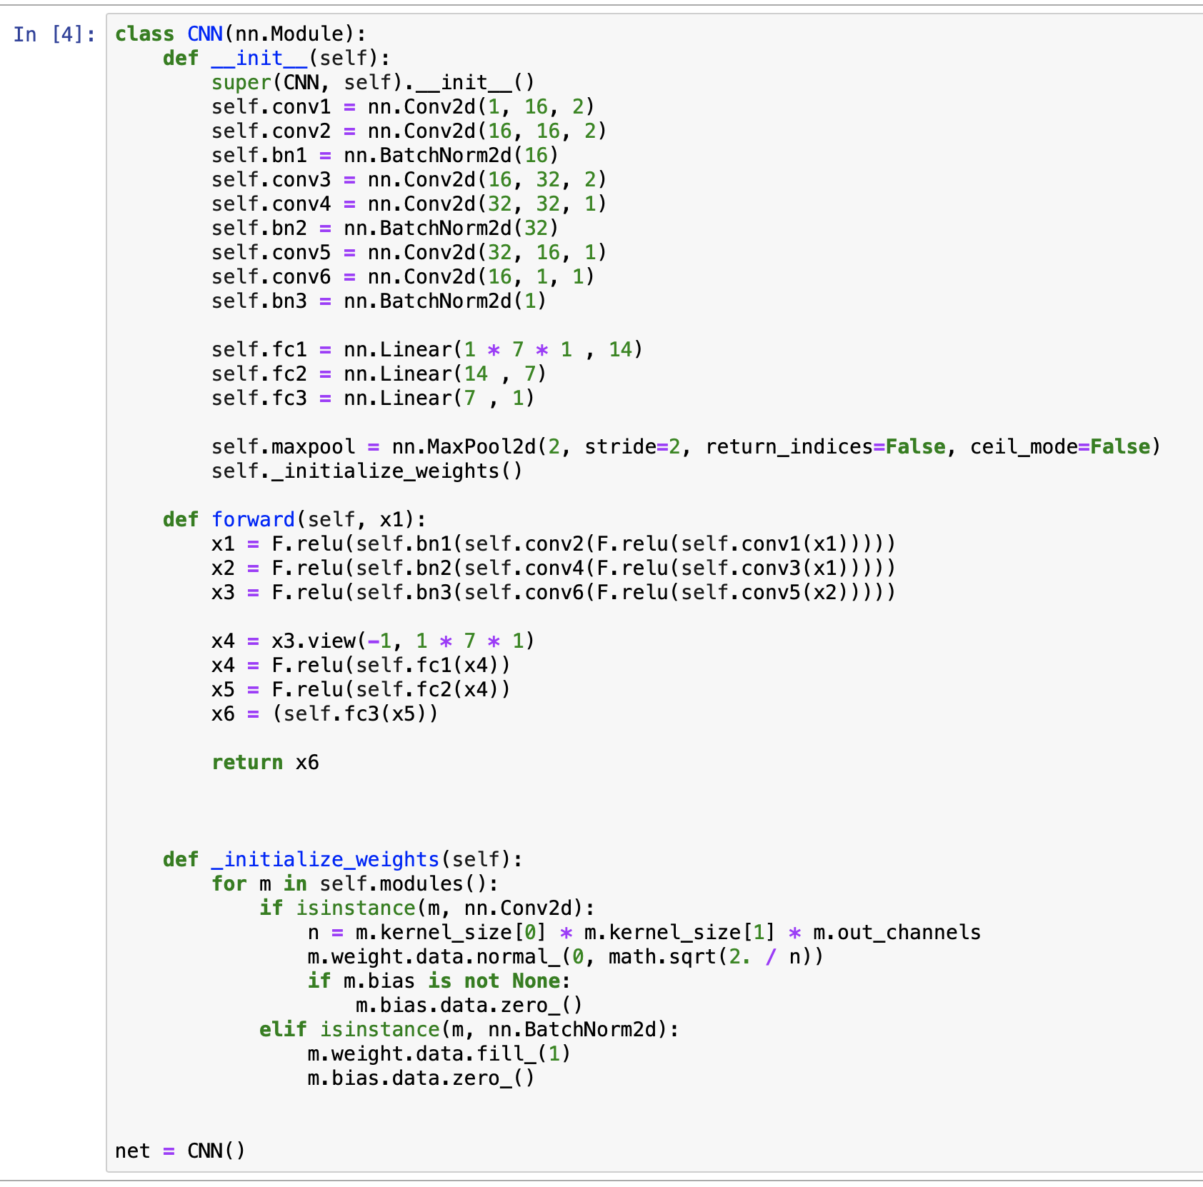

1. *Define the training process*

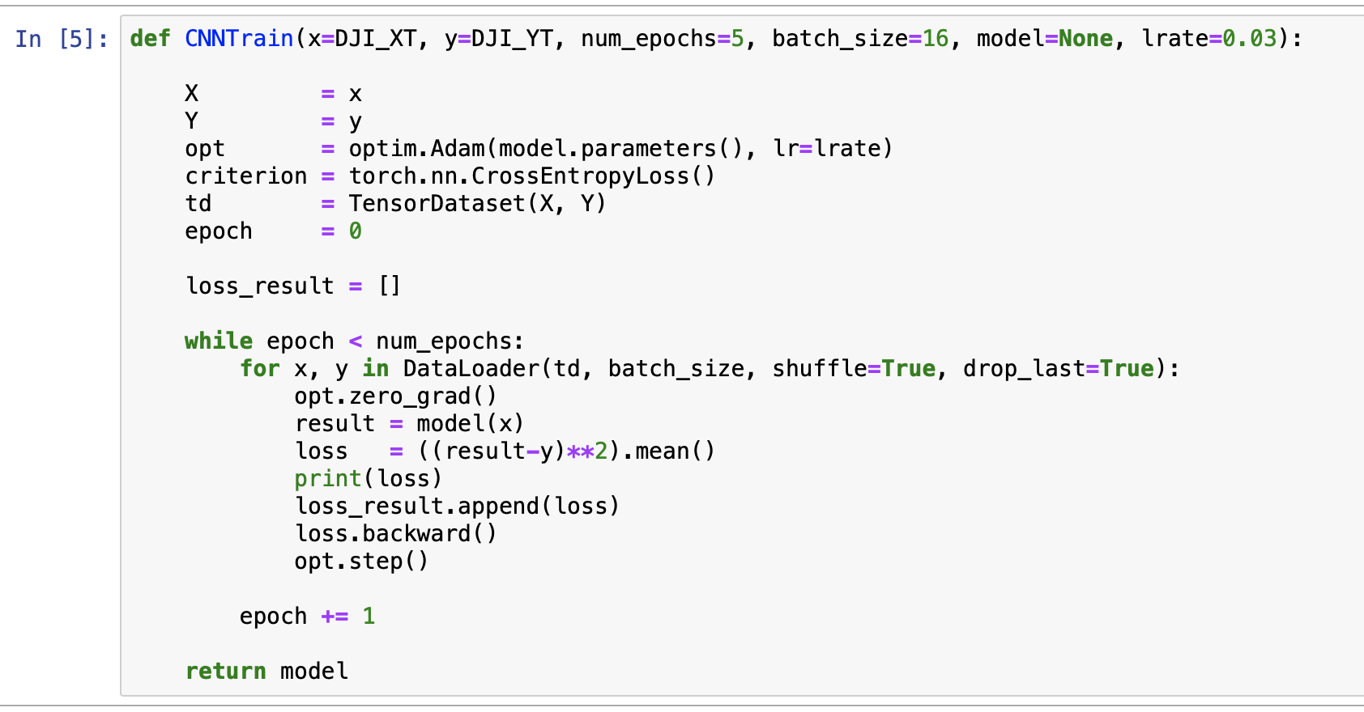

1. *Neural network training*

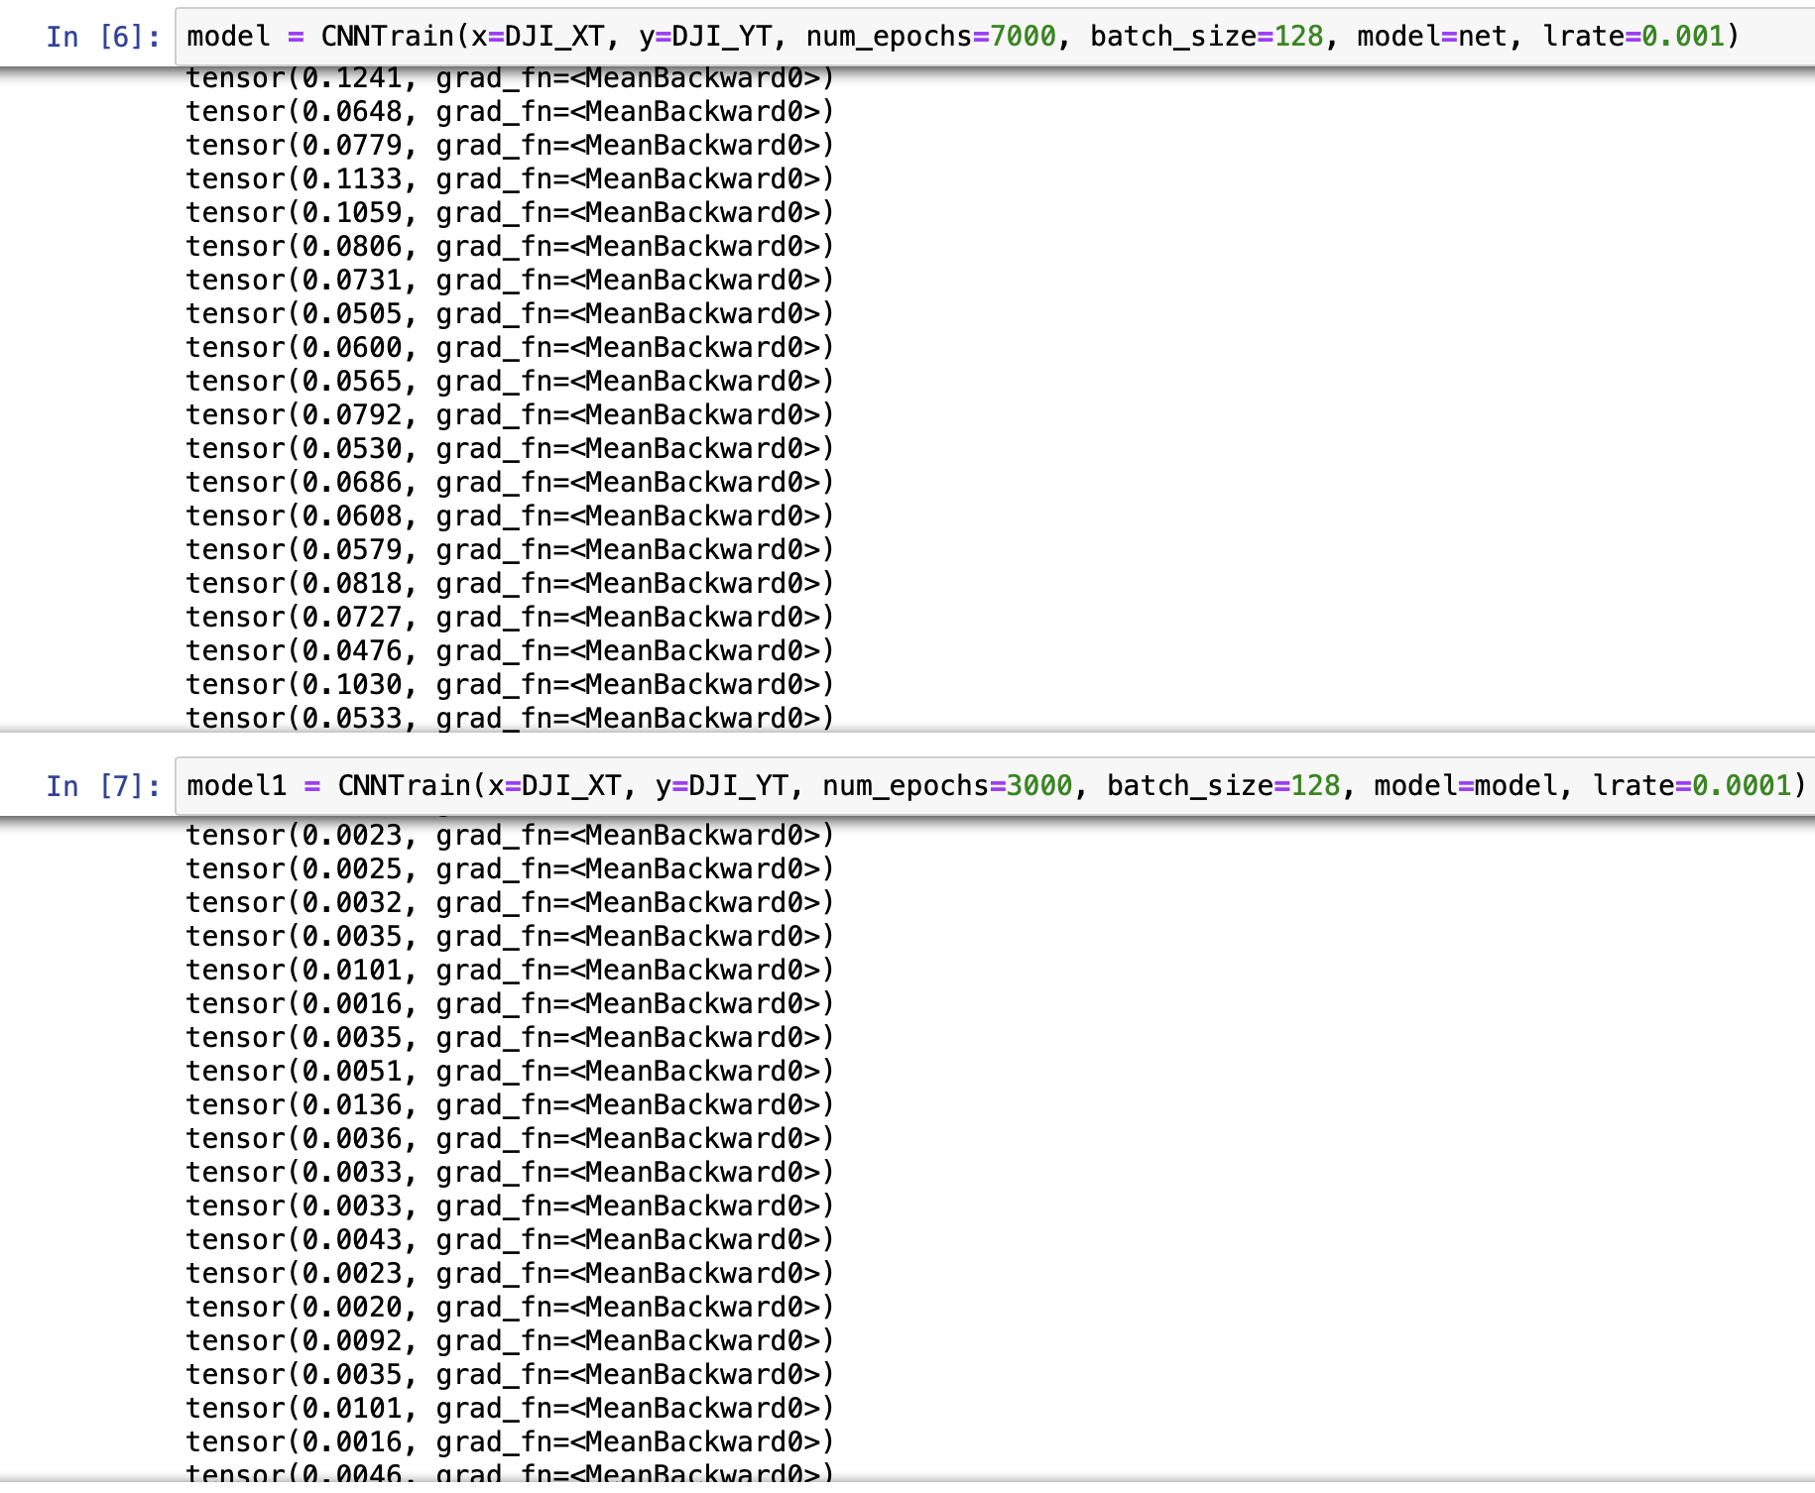

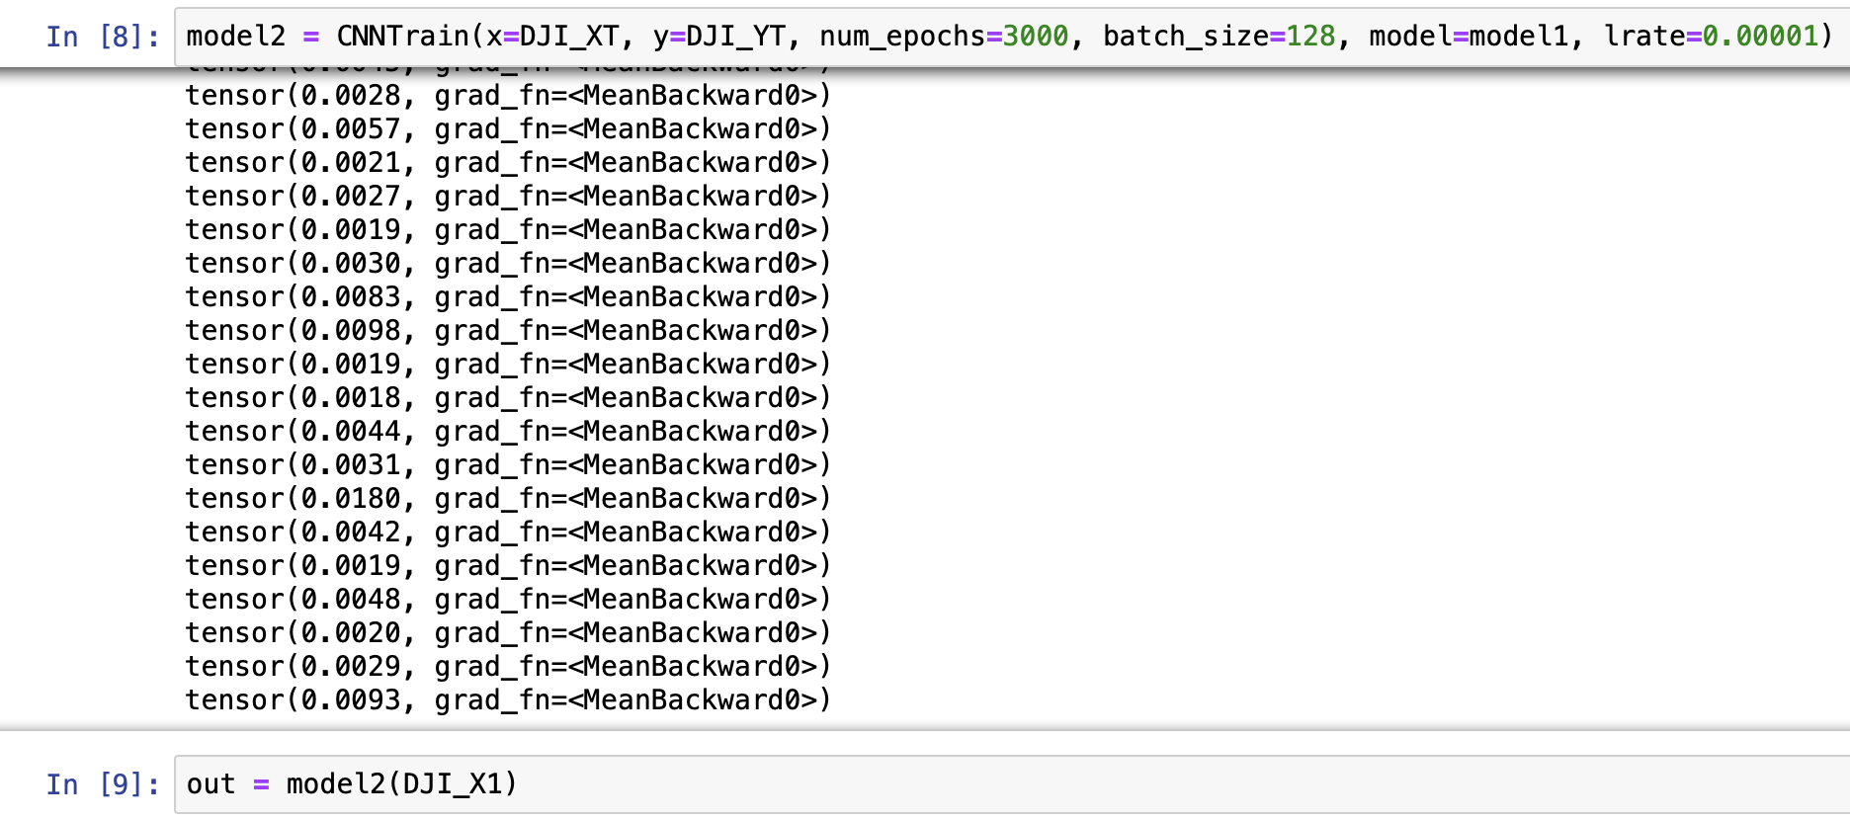

The neural network is gradually converging.

1. *Test the accuracy*

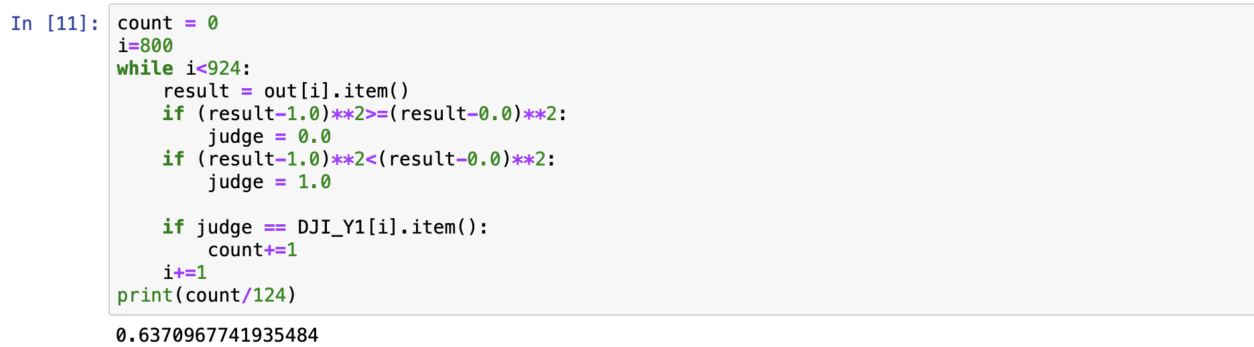

1. *ROC Curve*

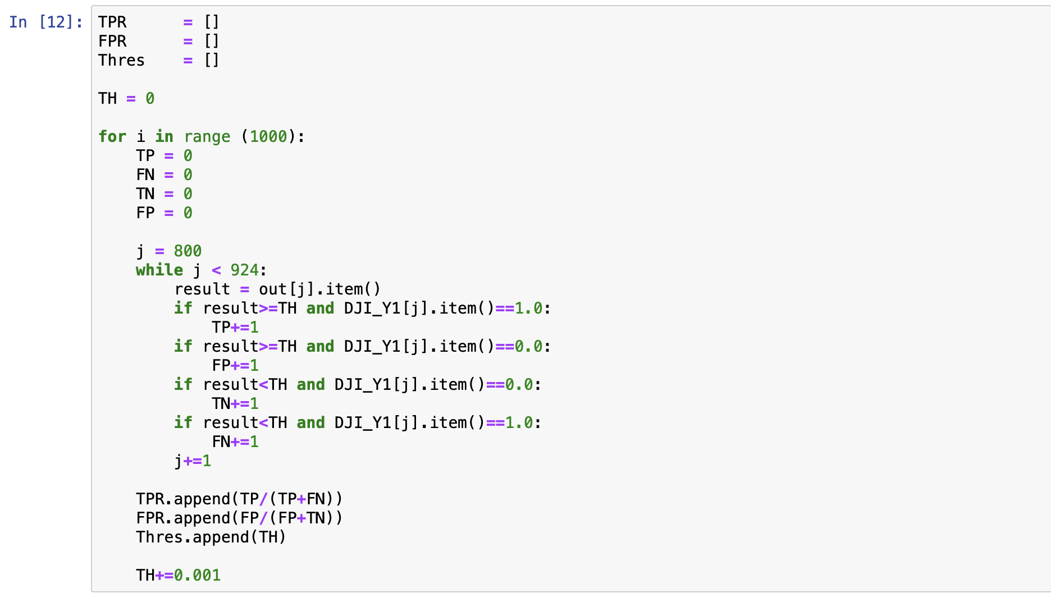

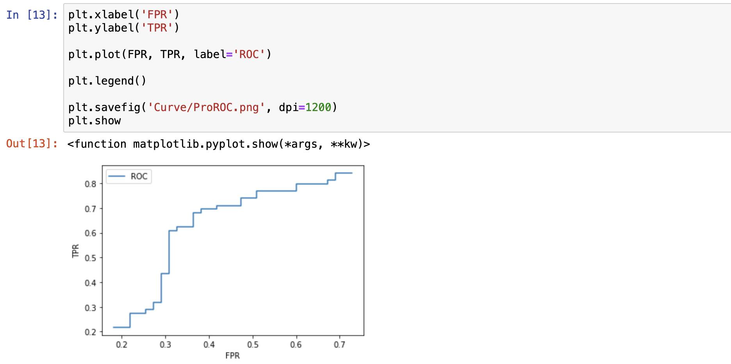

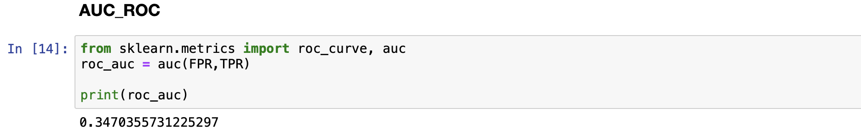

1. *Confusion Matrix*

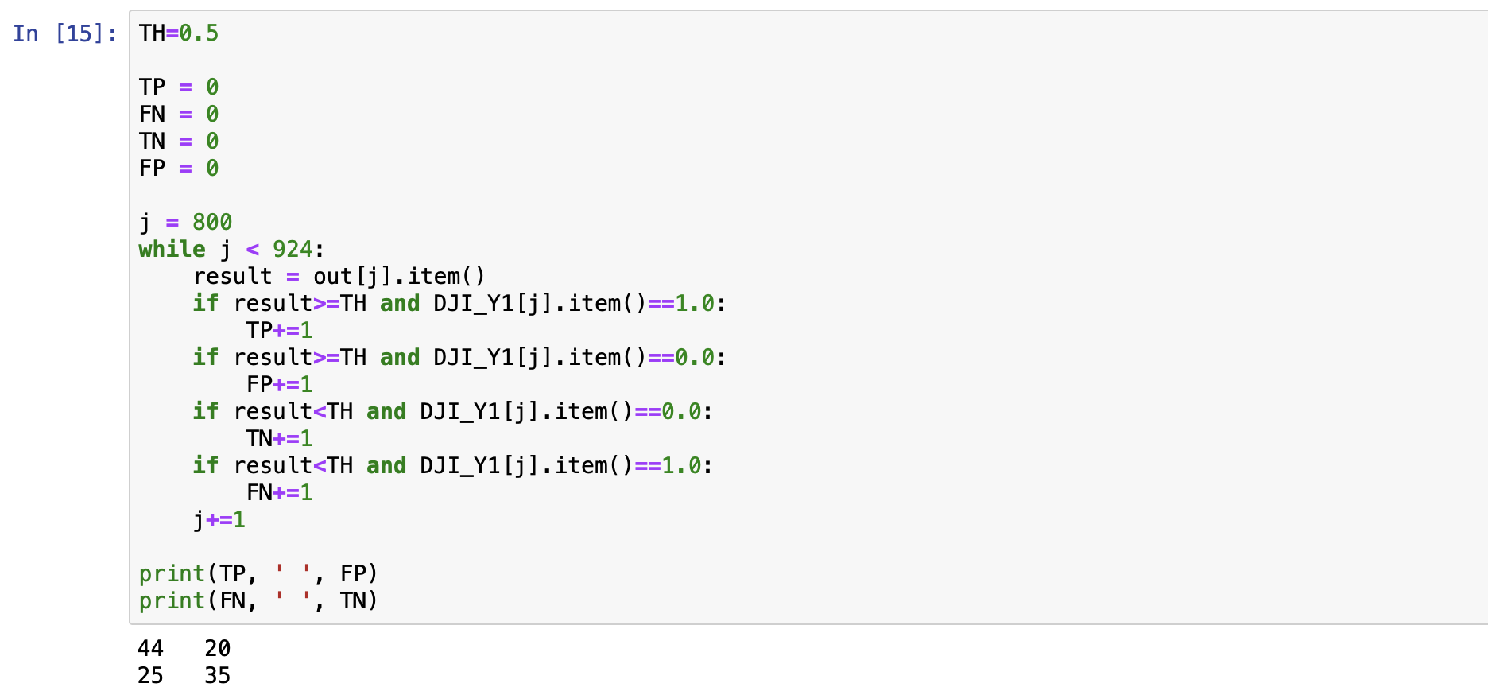

The color bar and final confusion matrix presenting are realized by Excel.